Upgrading SQL Server 2000 to SQL Server 2012: Upgrade Strategies
https://www.winwire.com/sql-server-2000-to-sql-server-2012-upgrade-strategies/

An upgrade is any kind of transition from SQL Server 2005, 2008, or 2008 R2 to SQL Server 2012. There are two fundamental strategies for upgrading, with two main variations in the second strategy:
• In-place upgrade: Using the SQL Server 2012 Setup program to directly upgrade an instance of SQL Server 2005, 2008, or 2008 R2. The older instance of SQL Server is replaced.
• Side-by-side upgrade: Using steps to move all or some data from an instance of SQL Server 2005, 2008, or 2008 R2 to a separate instance of SQL Server 2012. There are two main variations of the side-by-side upgrade strategy:
o One server: The new instance exists on the same server as the target instance.
o Two servers: The new instance exists on a different server than the target instance.

In-Place Upgrade
By using an in-place upgrade strategy, the SQL Server 2012 Setup program directly replaces an instance of SQL Server 2005, 2008, or 2008 R2 with a new instance of SQL Server 2012 on the same x86 or x64 platform. (An in-place upgrade requires that the old and new instances of SQL Server be on the same x86 or x64 platform.) This kind of upgrade is called “in-place” because the upgraded instance of SQL Server 2005/2008/2008 R2 is actually replaced by the new instance of SQL Server 2012. You do not have to copy database-related data from the older instance to SQL Server 2012 because the old data files are automatically converted to the new format. When the process is complete, the old instance of SQL Server 2005/2008/2008 R2 is removed from the server, with only the backups that you retained being able to restore it to its previous state.

Note: If you want to upgrade just one database from a legacy instance of SQL Server and not upgrade the other databases on the server, use the side-by-side upgrade method instead of the in-place method.
The figure below shows the before and after states of an in-place upgrade. In an in-place upgrade, SQL Server 2012 Setup replaces a legacy instance of SQL Server 2005, SQL Server 2008, or SQL Server 2008 R2.
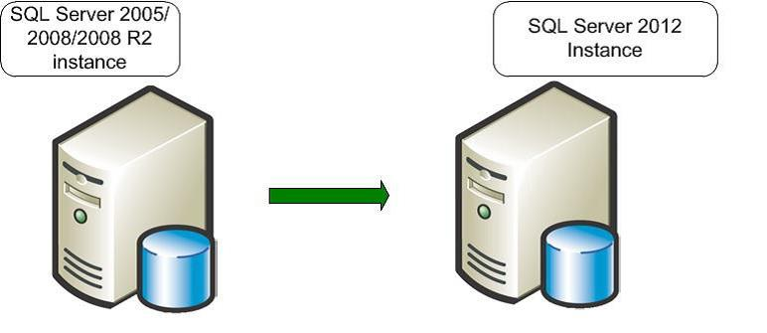
Note the following restrictions on an in-place upgrade:
• SQL Server 2012 Setup requires that all SQL Server components be upgraded together. Setup will detect all the components of the instance to be upgraded and will require that they all be upgraded immediately. In other words, you cannot upgrade only an instance of the SQL Server 2008 R2 Database Engine without also upgrading the Analysis Services component.
• An in-place upgrade from a 32-bit instance of SQL Server 2005/2008/2008 R2 (x86) to a 64-bit instance of SQL Server 2008 R2 (x64), or vice versa, is not supported. For more information, see the note in “Extended System Support (WOW64)” later in this chapter.
Here are the major steps that the SQL Server 2012 Setup program takes when you perform an in-place upgrade:
• The SQL Server 2012 Setup prerequisites—Microsoft .NET Framework 3.5 Service Pack 1 (SP1) or a later version, SQL Server Native Client, and so on—are installed. The legacy instance databases continue to be available.
• Setup checks for upgrade blocking issues, a small set of issues that will completely block an upgrade. If it finds any, Setup will list them. You must fix them and restart the upgrade process.
• If a pending restart exists, you will have to restart the computer.
• Setup installs the required SQL Server 2012 executables and support files.
• Setup stops the legacy SQL Server service. At this point, the legacy instance is no longer available.
• SQL Server 2012 updates the selected component data and objects.
• Setup removes the legacy executables and support files in addition to the legacy SQL Server 2000 R2 tools.
Legacy SQL Server 2005/2008/2008 R2 tools are not removed. (See Chapter 2, “Management and Development Tools,” for more information).
The new instance of SQL Server 2012 is now fully available. The legacy instance of SQL Server has been replaced and must be reinstalled from a backup if the need arises.

Side-by-Side Upgrade
In a side-by-side upgrade, instead of directly replacing the older instance of SQL Server, required database and component data is transferred from a legacy instance of SQL Server 2005/2008/2008 R2 to a separate instance of SQL Server 2012. It is called a “side-by-side” method because the new instance of SQL Server 2012 runs alongside the legacy instance of SQL Server, either on the same server or on a different server.
There are two important options when you use the side-by-side upgrade method:
• You can transfer data and components to an instance of SQL Server 2012 that is located on a different physical server or on a different virtual machine.

• You can transfer data and components to an instance of SQL Server 2012 on the same physical server.
Both options let you run the new instance of SQL Server 2008 R2 alongside the legacy instance of SQL Server 2005/2008/2008 R2. Typically, after the upgraded instance is accepted and moved into production, you can remove the older instance.

The figure below shows the before and after states of a side-by-side upgrade on two servers. A side-by-side upgrade to another server leaves the legacy instance of SQL Server 2005, SQL Server 2008, or SQL Server 2008 R2 unchanged.
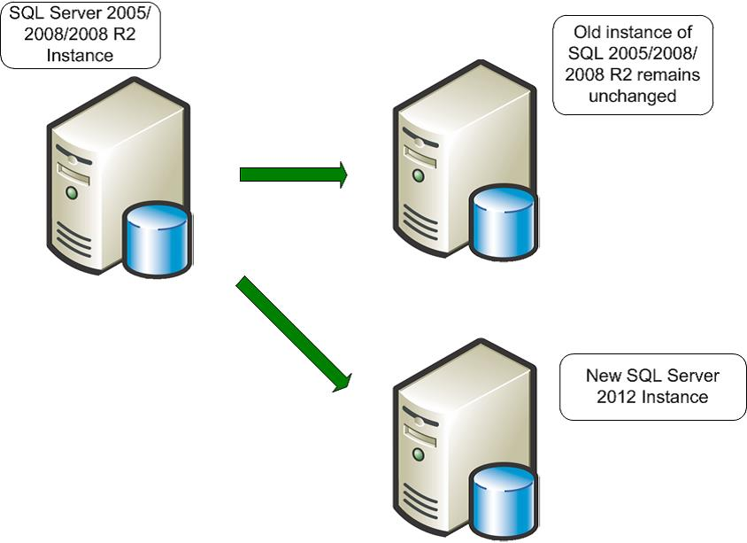
You can also use the side-by-side method to upgrade to SQL Server 2012 on the same server as the legacy instance of SQL Server 2005, SQL Server 2008, or SQL Server 2008 R2.

The figure below shows a side-by-side upgrade on the same server. Performing a side-by-side upgrade on the same server, leaving both instances running. Whether a side-by-side upgrade is to a separate instance on the same server or to a new instance on another server, data must be transferred in what is mostly a manual process. The result is two instances, legacy and new, that can run side by side.

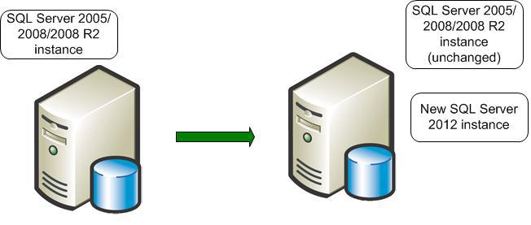
As just noted, the key point in a side-by-side upgrade is that you must manually transfer data files and other supporting objects from the older instance of SQL Server to the instance of SQL Server 2012. The SQL Server 2012 Setup program will not perform this task. The objects that you must transfer include the following:
• Data files
• Database objects
• SQL Server Analysis Services (SSAS) cubes
• Configuration settings
• Security settings
• SQL Server Agent jobs
• SQL Server Integration Services (SSIS) packages

Here are the main steps that you must perform when doing a side-by-side upgrade of SQL Server 2005, SQL Server 2008, or SQL Server 2008 R2 to SQL Server 2012:

• Install a separate instance of SQL Server 2012 on the legacy server or on a separate server. The legacy instance continues to be available.
• Run the SQL Server 2012 Upgrade Advisor against the legacy instance, and remove any upgrade blocker issues it finds.
• Stop all update activity to the legacy instance. This might involve disconnecting all users or forcing applications to read-only activity.
• Transfer data, packages, and other objects from the legacy instance to the instance of SQL Server 2012.
• Apply supporting objects such as SQL Server Agent jobs, security settings, and configuration settings to the new instance of SQL Server 2012.
• Upgrade SSIS (and potentially Data Transformation Services—DTS) packages to SSIS (see Chapter 17, “Integration Services,” for more information).
• Verify that the new instance supports the required applications by using validation scripts and user-acceptance tests.
• If the new instance passes validation and acceptance tests, redirect applications and users to the new instance. At this point, the new instance is available and databases are online.
• Keep your legacy instance for data recovery until you are absolutely confident that no problems exist on your new production database instance.
A side-by-side upgrade to a new server offers the best of both worlds: You can take advantage of a new and potentially more powerful server and platform, but the legacy server remains as a fallback if you encounter a problem. This method could also potentially reduce upgrade downtime by letting you have the new server and instances tested, up, and running without affecting a current server and its workloads.

You can test and address hardware or software problems encountered in bringing the new server online without any downtime of the legacy system. Although you would have to find a way to export data out of the new system to go back to the old system, rolling back to the legacy system would still be less time-consuming than a full SQL Server reinstall and restoring the databases, which a failed in-place upgrade would require.

The downside of a side-by-side upgrade is that increased manual interventions are required, so it might take more preparation time by an upgrade/operations team. However, the benefits of this degree of control can often be worth the additional effort.

Upgrading SQL Server 2000 to SQL Server 2012
You cannot upgrade a SQL Server 2000 instance or database to SQL Server 2012. For an in-place upgrade, upgrade the SQL Server 2000 instance to SQL Server 2005, SQL Server 2008, or SQL Server 2008 R2. Then apply SQL Server 2012 Setup.

For a side-by-side upgrade, first restore the SQL Server 2000 databases to SQL Server 2005, 2008, or 2008 R2 and then restore the resulting database to SQL Server 2012.

Comparing In-Place and Side-by-Side Methods
The difference between two upgrade strategies. Be aware that the main difference between an in-place upgrade and a side-by-side upgrade depends on the resulting instances. An in-place upgrade replaces the old instance so that only one instance remains.

Characteristics of an In-Place Upgrade vs. a Side-by-Side Upgrade

